JIM PREPARATORY SCH

NURSERY & PRIMARY

IKI-IKI

“Our God Is Able”

**MID TERM ONE EXAMINATIONS, 2024**

**CLASS : TOP**

**LEARNING AREA 4 : MATHEMATICAL CONCEPTS**

NAME: ______________________________________________________

1. **Find the next number.**

6 ______ 3 ______ 9 _______

11 _______ 1 _______ 19________

1. **Add the pictures.**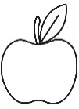

+

= _______

+

= _____

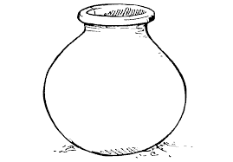

+

= _______

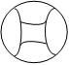

+

= _____

1. **Take away.**

-

-

5 2 = ______ 6 4 =__________

3 3 = _______ 10 6 = _________

-

-

1. **Name these shapes**.
2. **Fill in the missing numbers.**

0 , 1 , ___ 3 _____ , _______ , 6 , _____ 8

9 , _____ , 11 , _____ , ______ , 14 , ______

1. **Add the numbers.**

+

+

9 0 = _______ 2 3 = _______

6 4 = _______ 5 1 = _______

+

+

1. **Draw for the number.**

two chairs three eggs ten balls

2 pots one pencil

1. **Draw the beads.**

3 =

5 =

10 =

1. **Shade for the picture.**

6 =

2 =

10 =

0 =

1 =

3 =

***“Good Lu******ck”***